
TAMPERE UNIVERSITY OF TECHNOLOGY

Institute of Bioelectromagnetism

Bioelectromagnetism, Exercise 1

- In nerve and muscle cells the concentration ratios of the chloride and potassium ions between intracellular and extracellular fluids are approximately 1:30 (that is, for example ) and 38.8:1. What are the corresponding equilibrium voltages for chloride and potassium ions? (The value of the potential difference across the cell membrane that clamps the specific ionic flow)

- The permeabilities of potassium, sodium and chloride ions in the giant axon of a squid at 36 °C are P_{K}:P_{Na}:P_{Cl} = 1:0.04:0.45. The concentrations of the ions in intracellular and extracellular fluids are (10⁻³ mol/cm³):

[K⁺]_{i} = 3.45 [K⁺]_{o} = 0.10
[Na⁺]_{i} = 0.72 [Na⁺]_{o} = 4.55
[Cl⁻]_{i} = 0.61 [Cl⁻]_{o} = 5.40
Determine the resting membrane potential.

- A special single cell organism that lives in a natural mineral water spring has permeabilities of 0.09, 1.00 and 0.04 for the Cl⁻, K⁺ and Na⁺, respectively, and the following concentrations
[Cl⁻]_{i} = 178 [Cl⁻]_{o} = 0.47
[K⁺]_{i} = 135 [K⁺]_{o} = 83
[Na⁺]_{i} = 0.05 [Na⁺]_{o} = 118
To maintain the chloride gradient, this cell has a special chloride pump. Which direction does the pump have to move chloride in order to maintain the status?

- Show that the resting potential of the cell membrane can be expressed as

where
g_{i} = membrane conductance for ions i,
Vi = equilibrium voltage for ions i.

- Figure 1 represents an electrical model of a synapse. When impulse arrives to the presynaptic terminal the transmitter (acetylcholine ACH) is released to the synaptic cleft (after 0.5 ms). The cell membrane will become permeable to Na⁺ and K⁺ ions and the membrane potential tends to shift towards the mean of the Nernst voltages of the Na⁺ and K⁺ ions (=reversal voltage V_{rev}).
a) What is the resting potential of the presynaptic terminal (ACH-switch open)?
b) What is the reversal voltage, V_{rev} (ACH-switch closed)?

C_{m} (membrane capacitance per area) = 1 µF/cm²
Nernst voltages V_{K} = -100 mV and V_{Na} = 60 mV
R_{K} = 108 Ω, R_{Na} = 1.5*10⁹ Ω, ΔR_{K} = 10⁵ Ω, ΔR_{Na} = 10⁵ Ω.

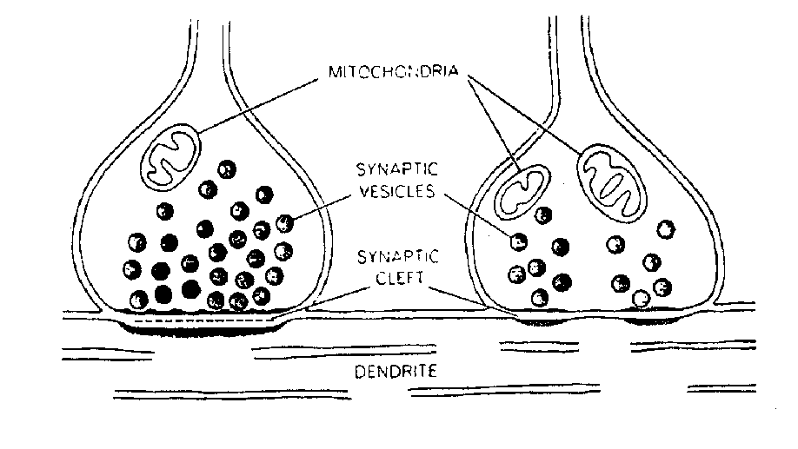
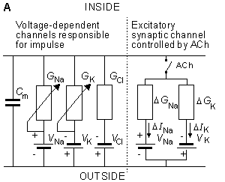
Figure 1. Synapse and its' electrical model.

