
TAMPERE UNIVERSITY OF TECHNOLOGY

Institute of Bioelectromagnetism

Bioelectromagnetism, Exercise 2

- The intracellular resistance of a nerve cell is 8.2*10⁶ Ω/cm (r_{i}). Resistance of the cell membrane is 1.5*10⁴ Ωcm and capacitance 12 nF/cm (c_{m}). Calculate the characteristic length and time constant of the axon. (start from the general cable equation to see how the time constant is derived)

- The rheobasic current of the nerve cell in the previous exercise is 2 mA.

a) What is the strength-duration equation of the cell? How long will it take to reach the stimulus threshold with a 2.5 mA stimulus current? What is the chronaxy of the cell?

b) Determine the propagation speed of an action pulse if the cell diameter is 100 µm and coefficient K = 10.47 1/ms and in propagation equation

ρ is the intracellular resistivity.

- Derive the equation of sodium conductance in voltage clamp measurement (with chemical clamping) using the Hodgkin-Huxley model.

- Cell membrane was studied with the voltage clamp measurement with a 56 mV positive voltage step. 2.5 ms after the step the membrane current is 0.6 mA/cm². When the sodium current was blocked with pharmaceutical the current was 1 mA/cm² (again, t = 2.5 ms after the step). Also, it was observed that the flow of sodium ions could be stopped with 117 mV increase in resting membrane potential. What is the sodium ion conductance G_{Na} (stimulation 56 mV, 2.5 ms)?

- The body surface ECG is measured using e.g. 26 to 256 electrodes. Figure 1 represents voltages of a normal body surface ECG measured at the end of a QRS complex. What can you say about the nature of the source according to this map?

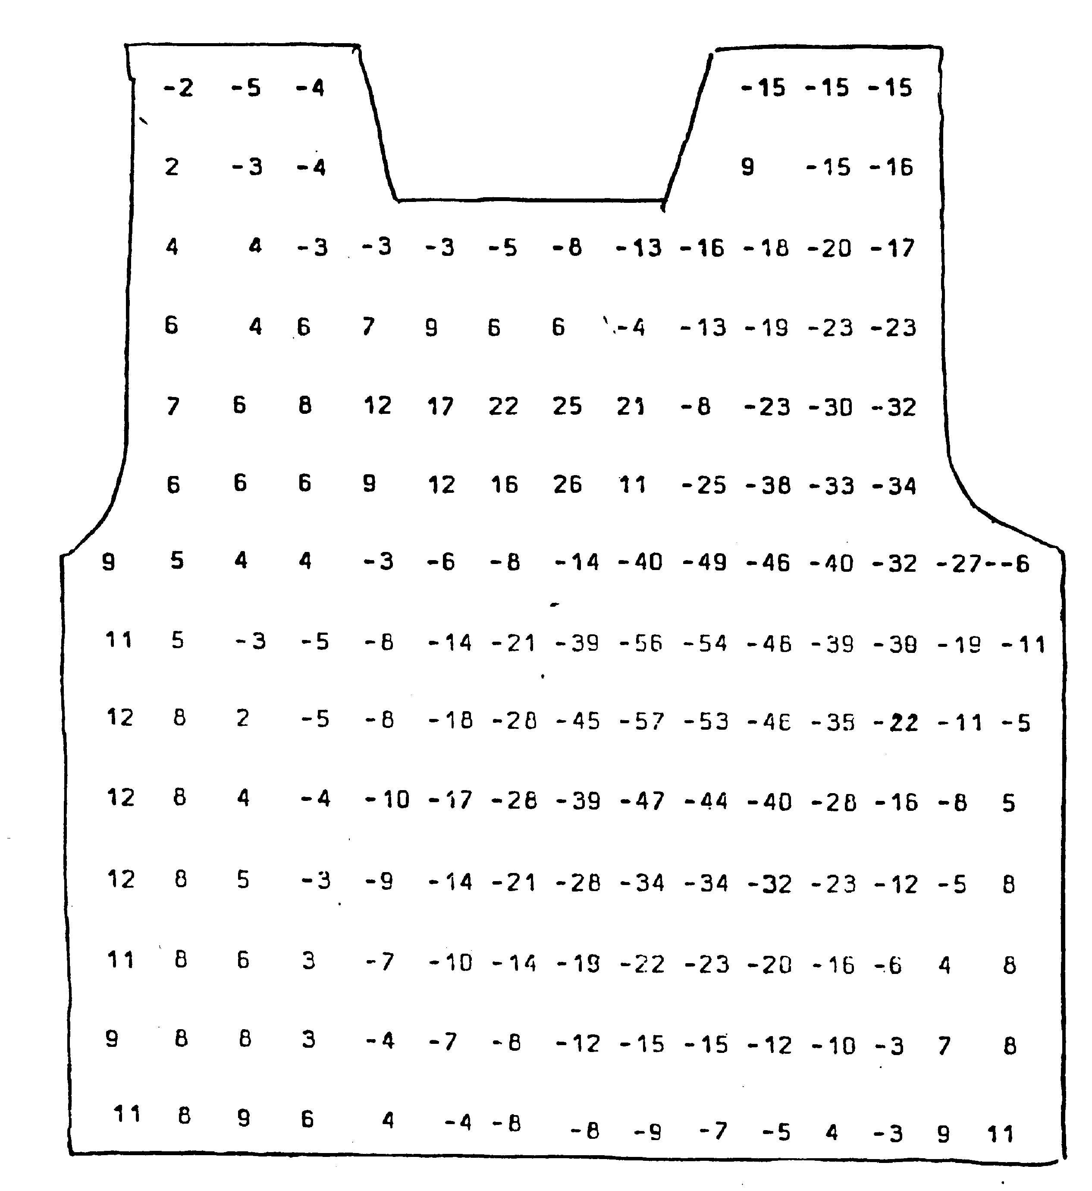

Figure 1. Anterior body surface map (BSM).

